Report title

Final document, version x.x
Publication date: [dd month yyyy]
DOI: xxxx
This document is an update to the alpha phase version 1.0 of the statistical framework.

Contents
Document information 2
Introduction to the SOSCHI project 3
Project partners 3
Styling 4
Tables 4
Charts and smart-art 5
Impact Pathway 6

Document information
Document title | [insert document title here]
Document location | Zenodo: https://zenodo.org/communities/soschi
Date and version | Error! Reference source not found. [dd month yyyy] - published version x.x
Authors | Antony Brown, Euan Soutter, Vijendra Ingole - ONS
DOI | https://zenodo.org/records/14051584
Preferred citation | Brown A, Soutter E, Ingole V. Standards for Official Statistics on Climate-Health Interactions (SOSCHI): Wildfires: introduction. Zenodo; 2024. doi: 10.5281/zenodo.14051584.
Related topic documents | xxxx
Contact | Climate and Health Team, Health and International Division, Office for National Statistics, Newport NP10 8XG, United Kingdom climate.health@ons.gov.uk
Copyright | This is an open access document published under a UK Open Government Licence 3.0 which is compatible with the Creative Commons CC-BY-SA 4.0 licence. You are free to copy, publish, distribute and adapt the information, provided you acknowledge the source and link to this publication or the ONS SOSCHI project home page. Statistical data used in the preparation of this document may be confidential under UK or other national laws. Enquiries concerning the availability of data can be made to the project team at climate.health@ons.gov.uk. Institutional logos are the property of the relevant institutions.

Styling

Section titles

Tables
Copy the table below to keep a clean and consistent style across all tables.
Table 1: Other relevant measures
Topic sub-area | Indicator | Measuring | Related Indicators
Vector-borne: Malaria | Temperature-humidity index (Relative humidity, soil moisture), altitude, runoff, waterlogging. | Hazard | UN: Climate Change Statistics and Indicators Self-Assessment Tool  The Lancet Countdown
Vector-borne: Malaria | Exposure of vulnerable populations to vector breeding sites due to increasing climate hazards.  Urban Vegetation Index. | Exposure and Vulnerability | UN global set of climate change statistics and indicators metadata  UKHSA Climate change and public health indicators scoping review: Water quality and quantity and their health impacts  The Lancet Countdown
Vector-borne: Malaria | Climate informed early warning systems, health sector response strategy plan | Adaptation | The Lancet Countdown

Charts and smart-art
This template is designed to apply on-brand colours automatically to charts and smart-art, however you may want to change these to suit your information. Right-click on this chart and save as a template to reuse the styling below.
Chart title

Image 1 – An example of an organisational structure chart

Impact Pathway
Figure 1 – Pathways between climate change and malaria
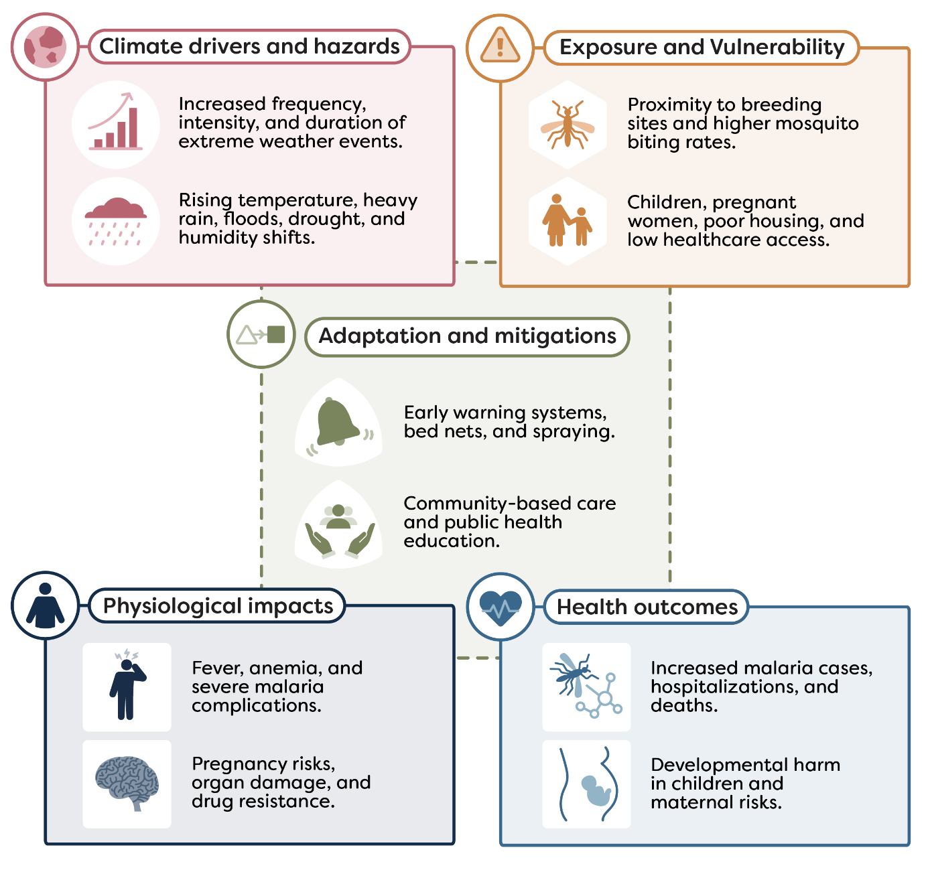

Disclaimer text

Overview of to the SOSCHI project
The impacts on health of rising temperatures, wildfires, extreme weather events and other direct and indirect effects of climate change are a major global concern. The most significant hazards and their impacts differ between countries and regions, as do the possibilities and priorities for climate change adaptation. National and local governments and other stakeholders need to have regular, reliable and comparable data to monitor climate impacts and inform adaptation strategies, based on a transparent and globally generalisable statistical framework. The SOSCHI project, led by the UK Office for National Statistics and funded by Wellcome, is developing a framework of indicators based on state-of-the-art statistical methods to measure climate-related health risks. To support global reporting and monitoring, we are also developing a knowledge-sharing platform, open-source tools, and R code. Our findings will also help highlight data gaps and help set the agenda for future improvement of data sources and methods.

Project partners
African Institute for Mathematical Sciences, Kigali, Rwanda
Cochrane Planetary Health Thematic Group, University of Alberta, Edmonton, Canada
Office for National Statistics, Newport, United Kingdom
Regional Institute for Population Studies, University of Ghana, Accra, Ghana
UK Health Security Agency, London, United Kingdom
United Nations Global Platform, New York, United States of America
The project is supported by Wellcome grant no. 224682/Z/21/Z

